Fama-French 5-Factor Model Analysis

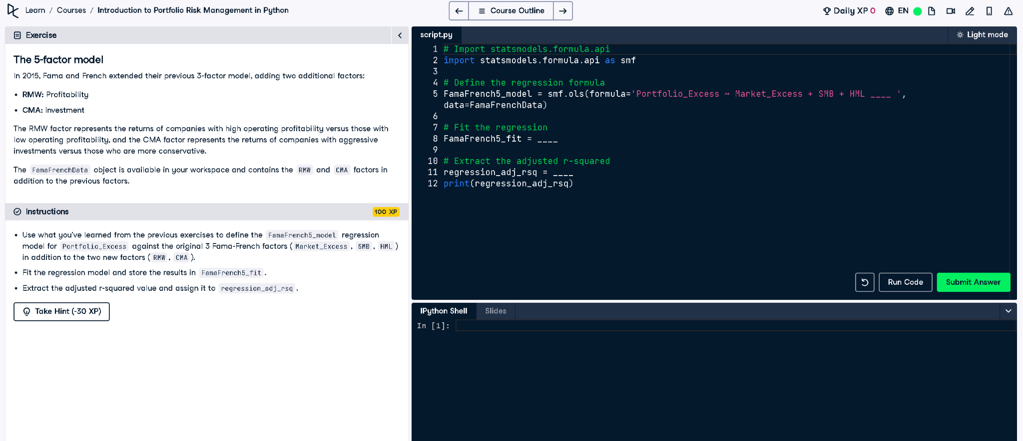

# Python Code

# Import statsmodels.formula.api  
import statsmodels.formula.api as smf  
  
# Define the regression formula  
FamaFrench5_model = smf.ols(formula='Portfolio_Excess ~ Market_Excess + SMB + HML + RMW + CMA',   
 data=FamaFrenchData)  
  
# Fit the regression  
FamaFrench5_fit = FamaFrench5_model.fit()  
  
# Extract the adjusted r-squared  
regression_adj_rsq = FamaFrench5_fit.rsquared_adj  
print(regression_adj_rsq)

# Explanation (Simple Words)

This Python code builds a model using 5 financial factors to explain a portfolio's extra returns. It fits the model with data and gives the adjusted R-squared value, showing how well the model works considering all the factors used.